

|  |
| --- |
| Link2Care Agenda |
| Quarter 4 [2022] |
| December 08, 2022: 10:00 AM – 11:00 AM |

# Action Items

|  |
| --- |
| 1. Study Update |
| 1. Placeholder |
|  |
|  |

Contents

Action Items 1

Study Participants 3

Phone and ClinCard Breakdown 4

Phone terminations 5

Visit Compliance 6

COVID -19 7

EMA and Study Completion Rates 8

Arrests 9

Bridge Case Session Minutes 10

Recruitment 11

Link2Care Study Update

**N =** **442 people screened as of** **December 05, 2022**

# Study Participants

**Table 1.** Demographic characteristics of all people screened for study inclusion.

| **Characteristic** | **Screened-in** | **Screened-out** |
| --- | --- | --- |
| **(n = 442)** | **(n = 68)** |
| **Age in years**, mean (sd) | 40.1 (10.8) | 45.2 (11.5) |
|  |  |  |
| **Gender**, n(%) |  |  |
| Male | 374 (84.6) | 60 (88.2) |
| Female | 61 (13.8) | 8 (11.8) |
| Other | 7 (1.6) | 0 (0.0) |
|  |  |  |
| **Race**, n(%) |  |  |
| Black or African American | 273 (61.8) | 52 (76.5) |
| White | 103 (23.3) | 11 (16.2) |
| Other | 66 (14.9) | 5 (7.4) |
|  |  |  |
| **Ethnicity**, n(%) |  |  |
| Non-Hispanic | 390 (88.2) | 66 (97.1) |
| Hispanic | 52 (11.8) | 2 (2.9) |

**Table 2.** Distribution of reasons for screen-out1.

| **Reason For Screen Out** | **n (%)** |
| --- | --- |
| Score <4 on REALM-SF | 54 (45.8) |
| Score <24 on Mini-Mental State Exam | 25 (21.2) |
| Incorrect Consent Reading | 14 (11.9) |
| Failure to Orient | 10 (8.5) |
| Other | 10 (8.5) |
| PT Plans to Move | 3 (2.5) |
| Walked Out Prior to Screen Out | 2 (1.7) |
| Total | 118 (100.0) |

1. This number is larger than the total number of people screened-out because each person could have been screened out for multiple reasons.

# Phone and ClinCard Breakdown

|  |  |
| --- | --- |
| **Table 3**. Payment card and phone loss. | |
| Total number of ClinCards distributed | 733 |
| Total number of participants with ClinCard replacements | 187 |
| Total number of phones distributed | 413 |
| Total number of participants with phone replacements | 134 |
| Number of participants with 1 replacement card (2 total cards) | 116 |
| Number of participants with 2 replacement card (3 total cards) | 47 |
| Number of participants with 3 replacement card (4 total cards) | 17 |
| Number of participants with 4 replacement card (5 total cards) | 6 |
| Number of participants with 5 replacement card (6 total cards) | 1 |

|  |  |
| --- | --- |
| **Table 4.** Phone distribution and replacement. |  |
|  | n (%) |
| Total number of phones distributed overall | 413 |
| Total number of participants in phone groups | 269 |
| Total number of participants w/ phone replacements | 134 |
| Total number of participants w/ phone replacement (**UCM+SP**) | 61 |
| Total number of participants w/ phone replacement (**L2C**) | 73 |
| Total number of participants in UCM+SP w/ >1 phone replacement | 5 |
| Total number of Participants in L2C w/ >1 phone replacement | 6 |

# Phone terminations

**Figure 1.** Reasons for phone terminations overall (N = 391 terminations).

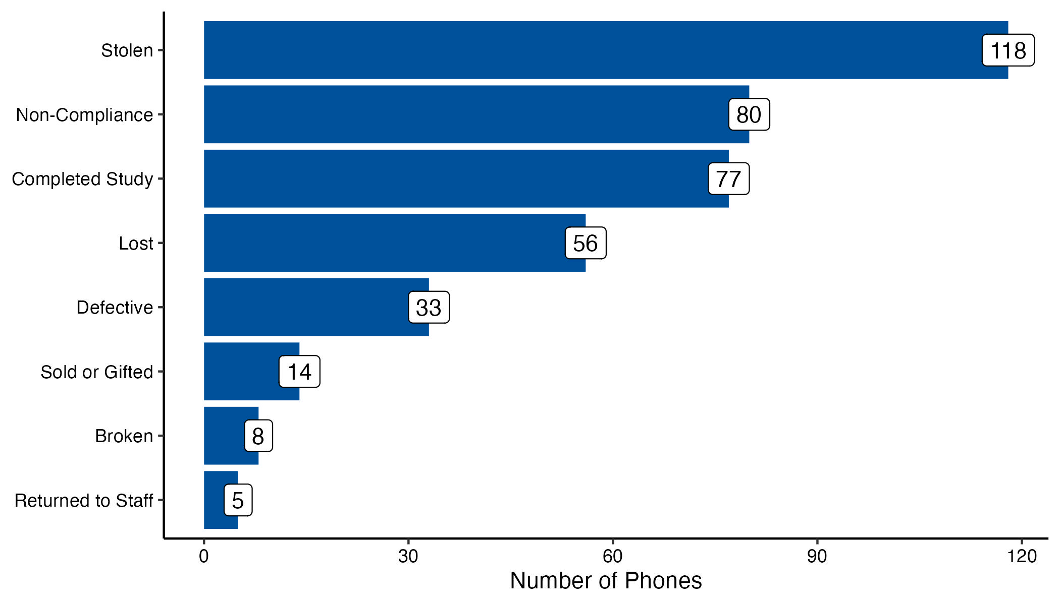

|  |  |  |  |
| --- | --- | --- | --- |
| **Table 5.** Reasons for phone terminations by informed consent form version | | | |
|  | **ICF #1**: Original EMA Structure  (P2001-P2073) | **ICF #2:** 15-Day EMA Comp & Non-compliance  (P2074-2153) | **ICF #3:** Increased EMA Payment  (P2154 and on) |
| **Reasons for Terminations** | **n (column %)** | **n (column %)** | **n (column %)** |
| Stolen | 33 (42.9) | 27 (32.1) | 58 (25.2) |
| Completed Study | 23 (29.9) | 13 (15.5) | 41 (17.8) |
| Non-Compliance | 0 (0.0) | 18 (21.4) | 62 (27.0) |
| Lost | 13 (16.9) | 15 (17.9) | 28 (12.2) |
| Defective | 2 (2.6) | 9 (10.7) | 22 (9.6) |
| Sold or Gifted | 3 (3.9) | 2 (2.4) | 9 (3.9) |
| Returned to Staff | 0 (0.0) | 0 (0.0) | 5 (2.2) |
| Broken | 3 (3.9) | 0 (0.0) | 5 (2.2) |
| **Total** | **77 (100)** | **84 (100)** | **230 (100)** |

# Visit Compliance

|  |  |
| --- | --- |
| **Table 6.** Number and percent of participants per L2C group (n randomized = 406). | |
| **L2C Group** | **n (percent)** |
| UCM+SP | 135 (33.3) |
| UCM | 137 (33.7) |
| L2C | 134 (33.0) |

|  |  |  |
| --- | --- | --- |
| **Table 7.** Number and percent of participants who completed visits 1 through 5. | | |
| **Visit Number** | **Overall**  **N =** **442**  n (percent) | **Participants Who Attended Visit 2**  **N =** **406**  n (percent) |
| 1 | 442 (100.0) | - |
| 2 | 406 (91.9) | 406 (100.0) |
| 3 | 296 (68.5) | 296 (74.7) |
| 4 | 222 (53.6) | 222 (58.7) |
| 5 | 185 (49.3) | 185 (54.6) |
|  |  |  |

# COVID -19

|  |  |
| --- | --- |
| **Table 8**. COVID-19 phone (N = 58), REDCap (N = 75), and combination (N = 1) interviews since protocol change on 3/17/2020. | |
|  | Number of Interviews |
| **Overall** | **134** |
| *L2C Groups* |  |
| UCM | 37 |
| UCM+SP | 52 |
| L2C | 45 |
| *L2C Visits* |  |
| Visit 2 | 1 |
| Visit 3 | 44 |
| Visit 4 | 46 |
| Visit 5 | 43 |
| Notes. N=total number of phone interviews conducted. Some participants have had >1 remote interview. | |

# EMA and Study Completion Rates

On 11/21/2018, we changed our approach to compensating participants for completing Ecological Momentary Assessments (EMA). Participants 2011-2073 (n = 47) were compensated using initial payment approach (IPA). Participants 2074 and above were compensated using revised payment approach (RPA). The figures below compare the differences in EMAs completed by payment approach using multiple different metrics.

**Figure 2.** Number of Ecological Momentary Assessments (EMA) completed by 15-day cycle and payment approach.

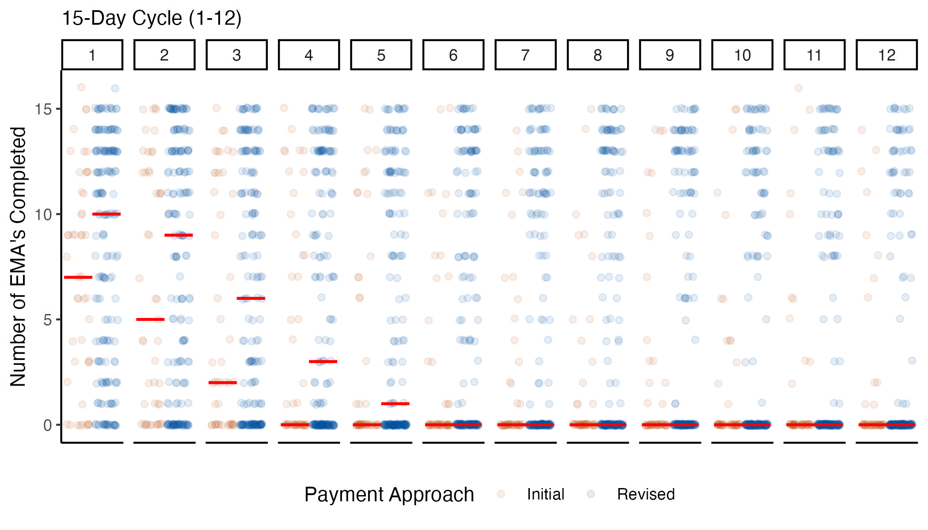

1. Red lines are equal to the median number of EMA's completed for each cycle and pay approach.

**Figure 3.** Percentage of participants who completed zero Ecological Momentary Assessments (EMA) by 15-day cycle and payment approach.

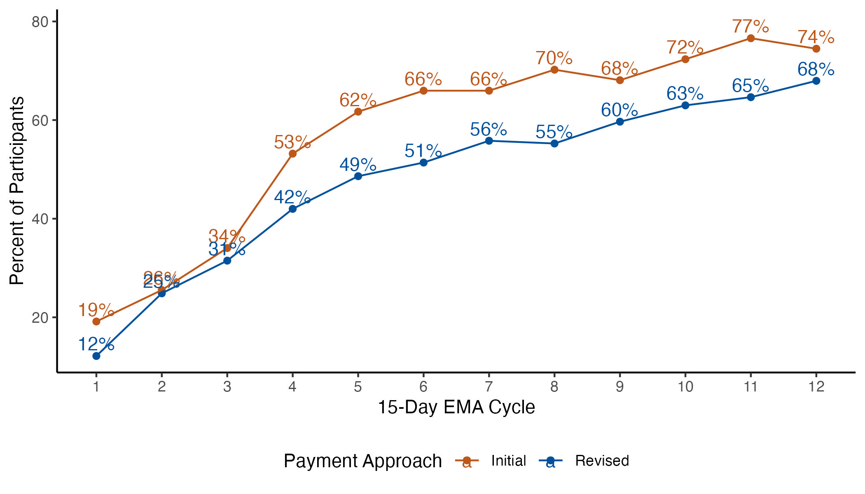

**Figure 4.** Percentage of participants who completed seven or more Ecological Momentary Assessments (EMA) by 15-day cycle and payment approach.

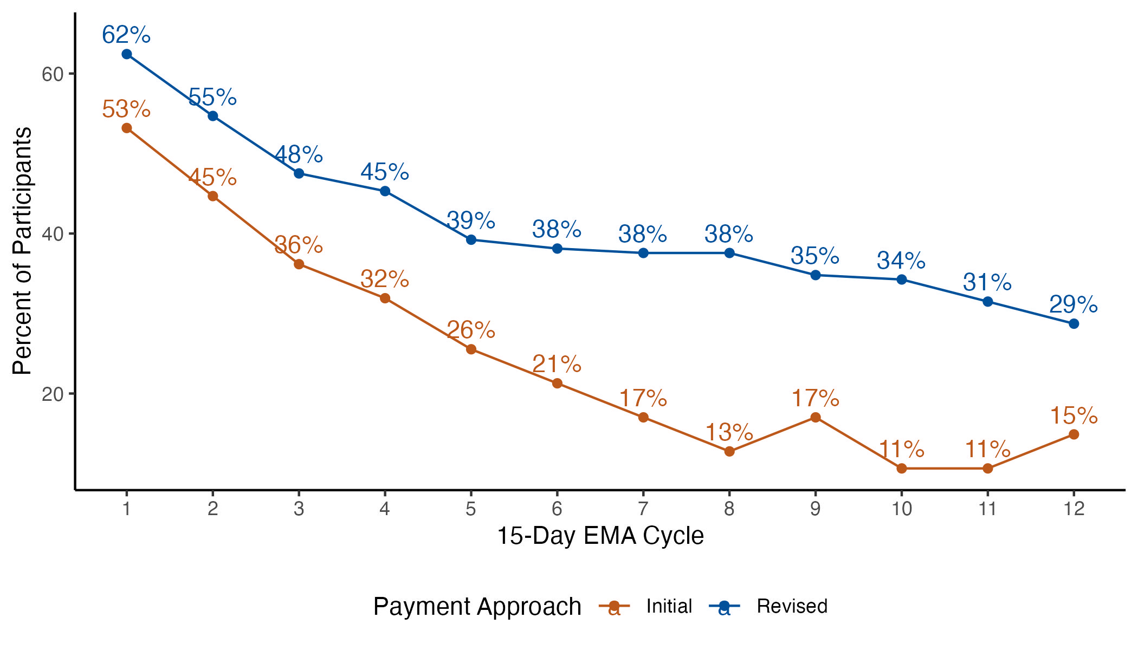

# Arrests

|  |  |
| --- | --- |
| **Table 10.** Arrests by treatment arm 12 months after enrollment. | |
| **Treatment Condition** | **Arrested**  n (row percent) |
| *Overall (n=304)* | 137 (45.1) |
| UCM (n=93) | 43 (46.2) |
| UCM+SP (n=94) | 42 (44.7) |
| L2C (n=92) | 38 (41.3) |
| NS V2 (n=25) | 14 (56.0) |
|  | |

# Bridge Case Session Minutes

|  |  |  |  |  |
| --- | --- | --- | --- | --- |
| **Table 11.** Number and percent of participants who used Bridge case management (N = 406)1 | | | | |
|  | **Number of Participants (%)** | | | |
| **Overall**  **(N=406)** | **UCM**  **(N=137)** | **UCM+SP (N=135)** | **L2C**  **(N=134)** |
| Used at least one session of regular case management | 301 (74.1) | 106 (77.4) | 96 (71.1) | 99 (73.9) |
| Used at least one session of crisis case management | 37 (9.1) | 14 (10.2) | 13 (9.6) | 10 (7.5) |
| Used at least one session of other case management | 200 (49.3) | 72 (52.6) | 60 (44.4) | 68 (50.7) |
| Used **no** forms of Bridge case management | 86 (21.2) | 25 (18.2) | 33 (24.4) | 28 (20.9) |
| Note: Categories of case management are not mutually exclusive, so percentages may exceed 100.  1. Only includes participants who were randomized to a study arm and have a row in the bridge session minutes. | | | | |

|  |  |  |  |  |  |
| --- | --- | --- | --- | --- | --- |
| **Table 12**. Number and duration of case management sessions used1 | | | | | |
|  | **Overall**  **(N=366)** | **UCM**  **(N=102)** | **UCM+SP**  **(N=102)** | **L2C**  **(N=100)** | | |
| **Case management of any type** |  |  |  |  | | |
| Sessions per participant, median (range) | 4 (0-66) | 5 (0-66) | 3 (0-57) | 4 (0-54) | | |
| Total minutes of sessions per PT, median (range) | 105 (0-1,910) | 125 (0-1,800) | 85 (0-1,630) | 92.5 (0-1,910) | | |
| **Regular Case Management** |  |  |  |  | | |
| Sessions per participant, median (range) | 6 (1-48) | 7 (1-46) | 5 (1-47) | 6 (1-48) | | |
| Total minutes of sessions per PT, median (range) | 190 (15-1,845) | 215 (30-1,615) | 165 (20-1,525) | 195 (15-1,845) | | |
| **Crisis Case Management** |  |  |  |  | | |
| Sessions per participant, median (range) | 1 (1-8) | 1 (1-7) | 1 (1-8) | 1 (1-3) | | |
| Total minutes of sessions per PT, median (range) | 35 (10-265) | 35 (10-235) | 45 (10-265) | 30 (10-80) | | |
| **Other Case Management** |  |  |  |  | | |
| Sessions per participant, median (range) | 2 (1-19) | 2 (1-19) | 2 (1-16) | 2 (1-14) | | |
| Total minutes of sessions per PT, median (range) | 10 (2-150) | 10 (5-150) | 15 (2-102) | 12.5 (5-110) | | |
| 1. Only includes participants who were randomized to a study arm. | | | | |  |

# Recruitment

**Figure 5.** Recruitment by month.

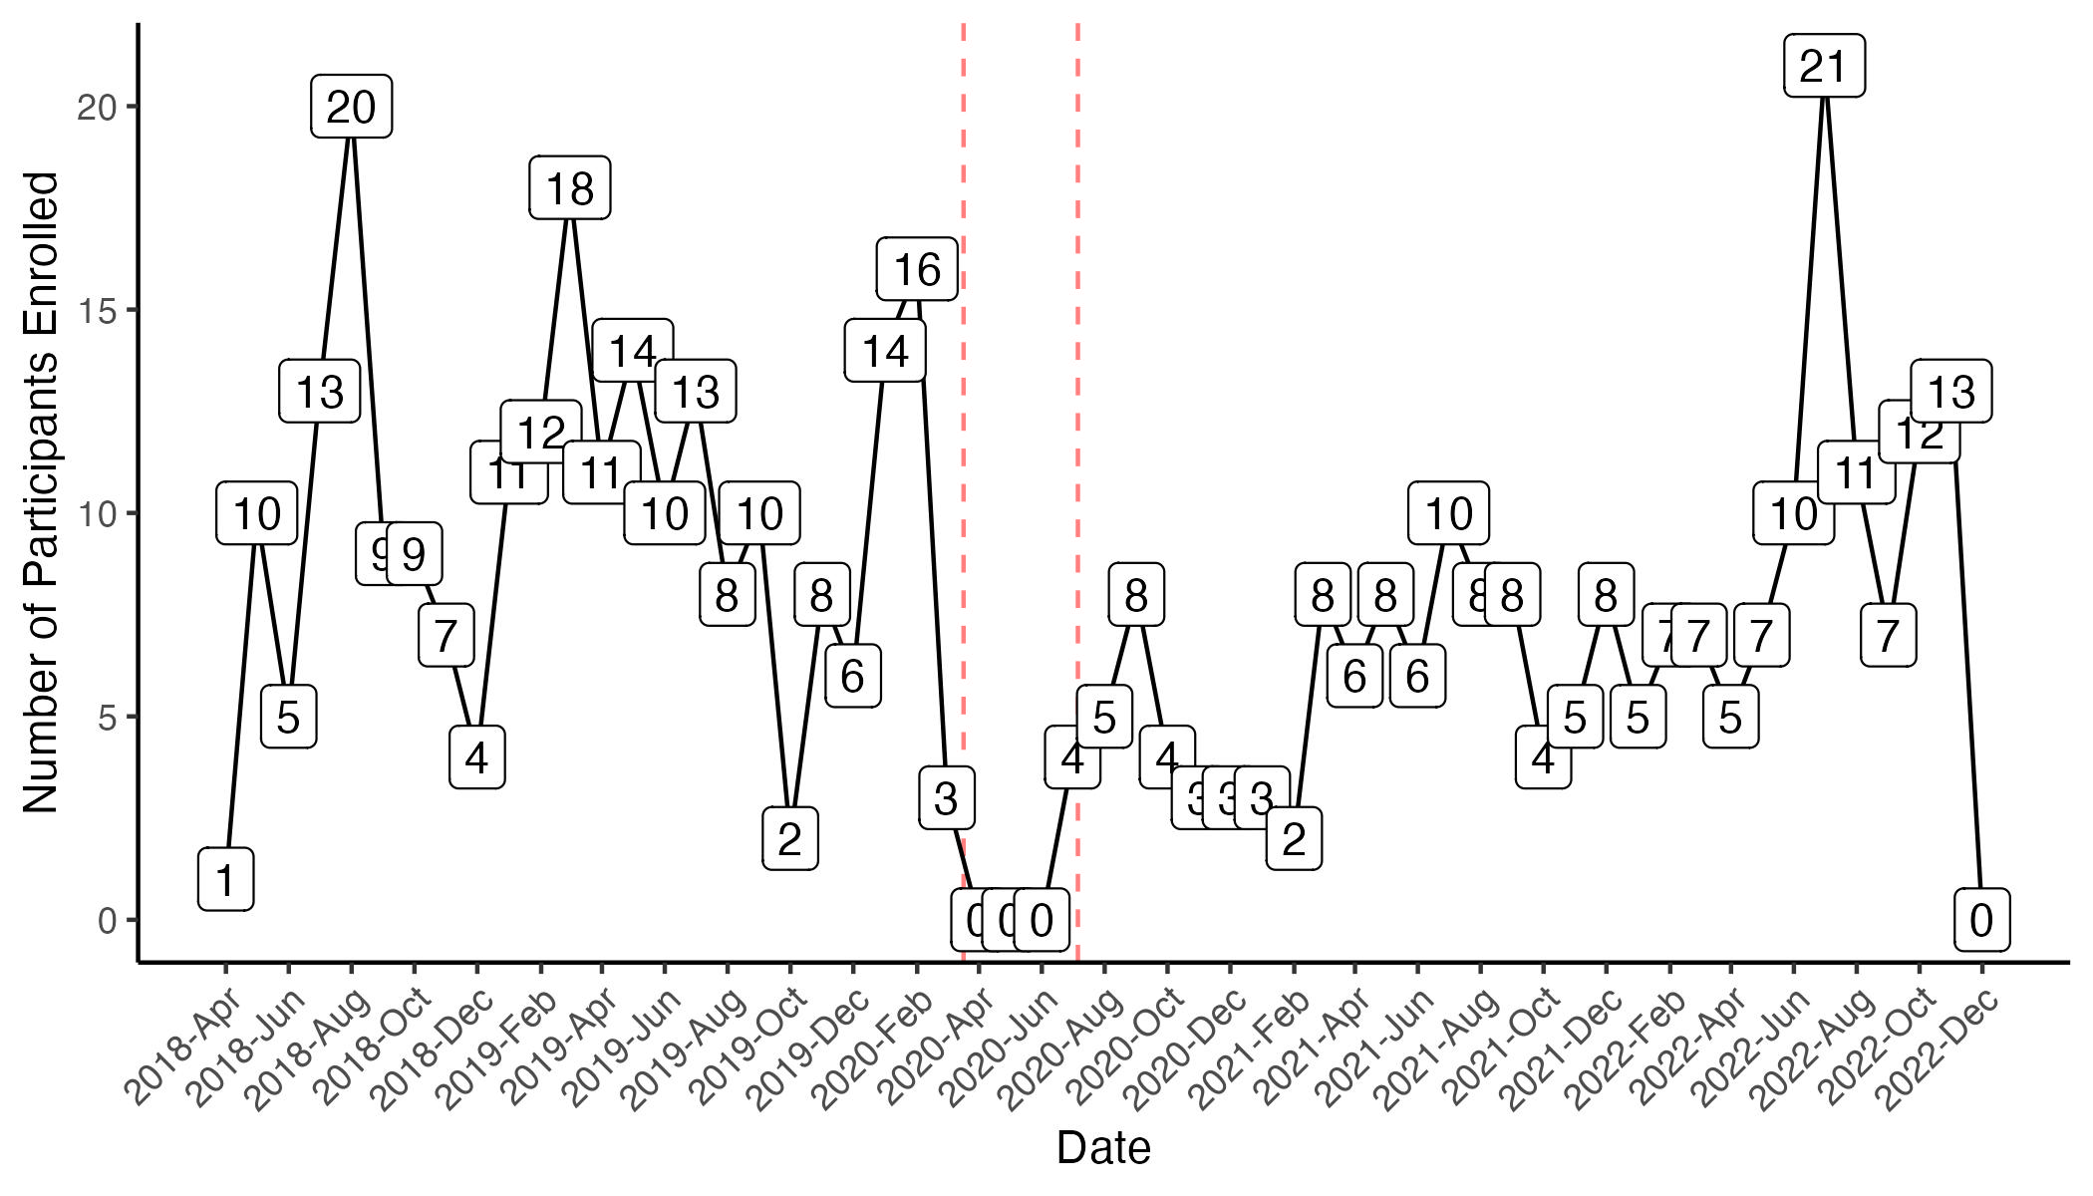

1. Recruitment began on April 17, 2018 and ended temporarily on March 17, 2020 due to COVID-19 and began again on July 6, 2020

2. Graph does not include participants that screened out during baseline assessment

Average recruitment (*2020-03-17 to 2020-07-05 not included in the denominator*):

* Overall = 8.3 per month
* Pre-COVID = 9.8 per month
* Post-COVID = 7.2 per month

**Figure 6.** Monthly recruitment stratified by year.

